Movie Landing Page Website Design

Name: KHAGGA VENKATANARASIMHAM

Mail Id : janaganamana253@gmail.com

Phn No : 6300219430

Roll N0 : 20HU1A0562

College Name : Chebrolu engineering college

**Source Code:**

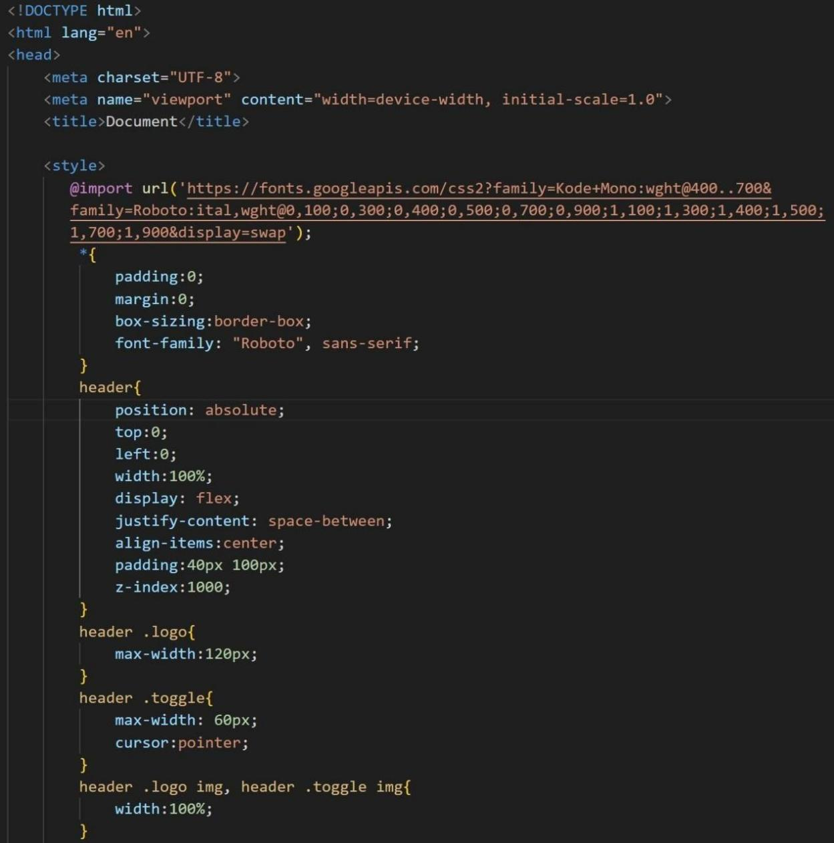

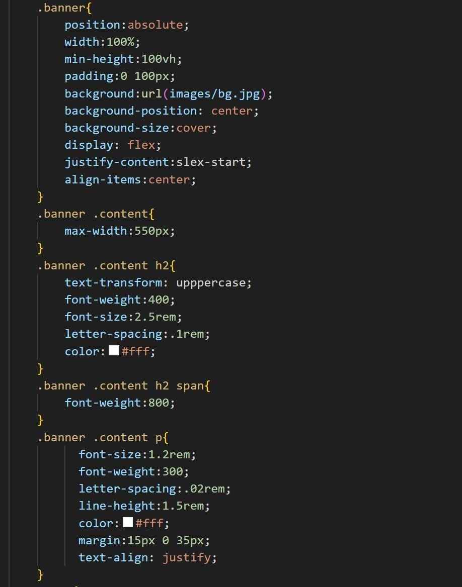

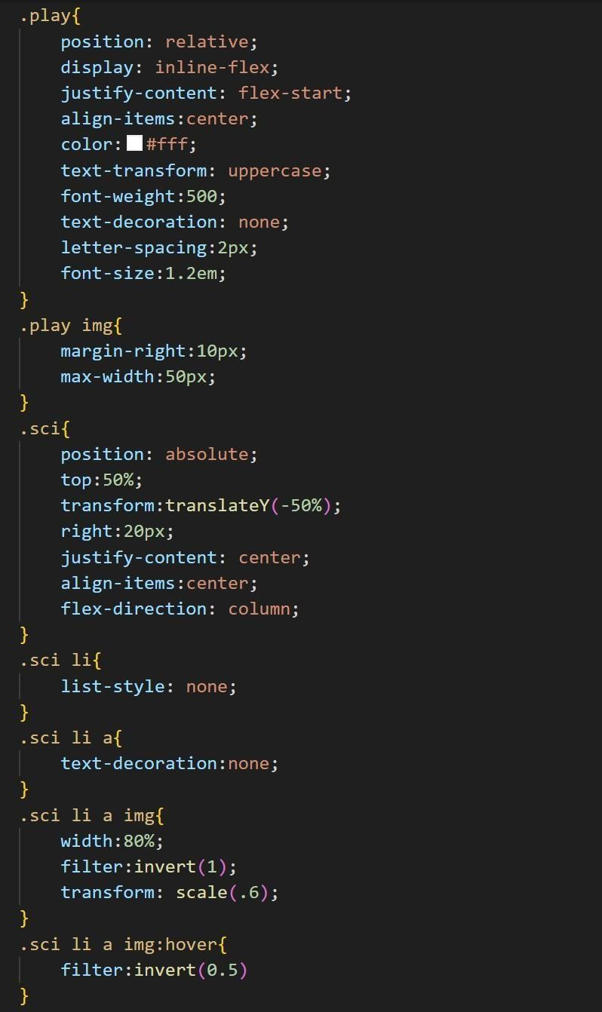

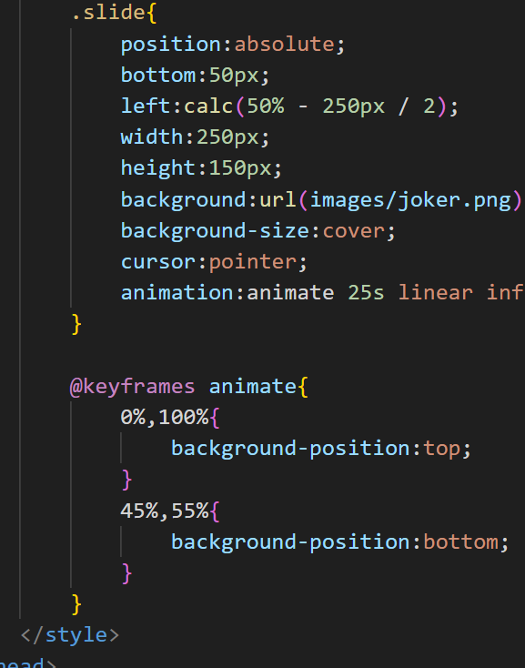

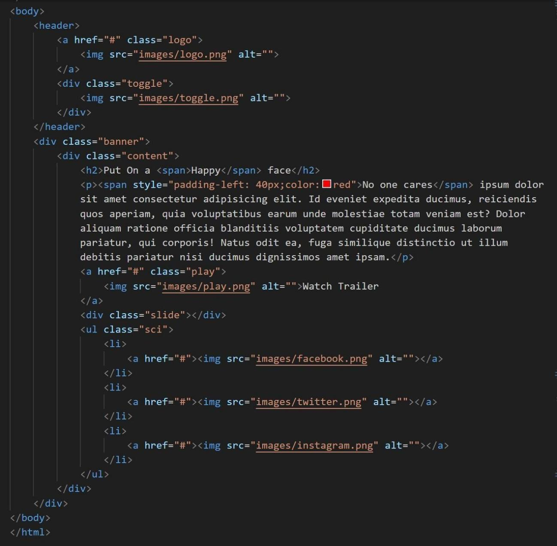



**Output :**